7.3 SonarQube with Jenkins

This section will guide you to:

* Install and configure SonarQube with Jenkins.

**Please Note:** To work with SonarQube in Jenkins, it is necessary that JDK, Git, and Maven are set in Jenkins as shown below or as per your installation directories.

This guide has four subsections, namely:

7.3.1 Install SonarQube on your local system

7.3.2 Install and configure SonarQube plugin in Jenkins

7.3.3 Push code to GitHub repositories

**Step 7.3.1:** Install SonarQube on your local system

* Steps to setup **SonarQube**in Windows machine.

1. Download the Community edition from **https://www.sonarqube.org/downloads/**
2. Extract .zip file and navigate to the *bin* folder.
3. Based on the machine configuration, go to folders **windows-x86–32** and **windows-x86–64**
4. Run **StartSonar.bat** and after a few minutes, it will start your SonarQube server.
5. Navigate to **http://localhost:9000/** and the below screen will appear:

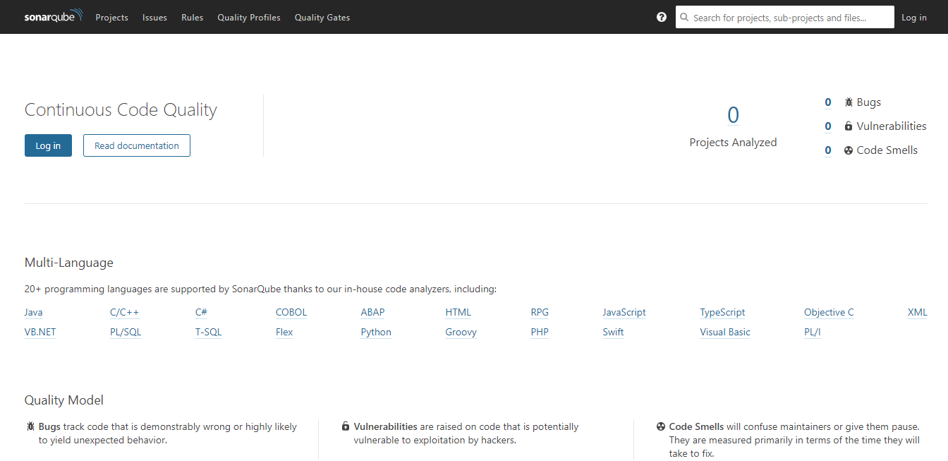

**Step 7.3.2:** Install and configure SonarQube plugin in Jenkins

* Open SonarQube server and go to Administration > Security > Users > Tokens (image 1)> Generate token with some name > Copy the token (image 2), it will be used in Jenkins for Sonar authentication.

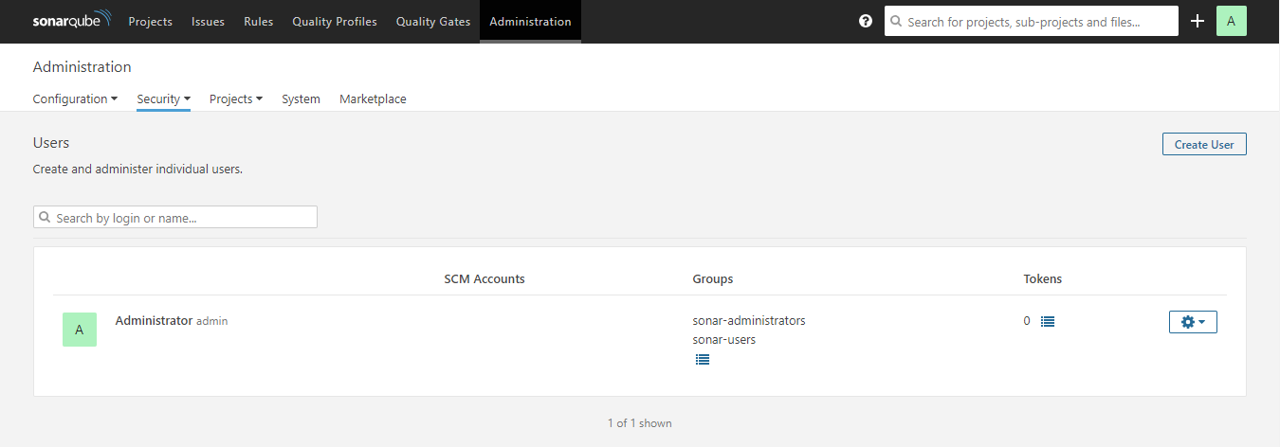

**Image 1**

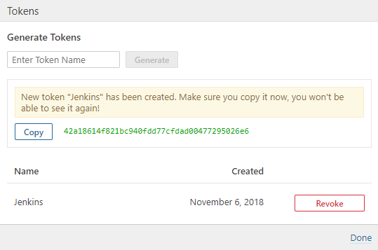

**Image 2**

* Login to Jenkins dashboard and go to **Manage Jenkins** > **Configure system**> **SonarQube server** section > Add SonarQube > provide Name, and Server URL as **http://<IP>:<port>** > , add authentication token copied from SonarQube Server > **Apply** ,and click **Save.**

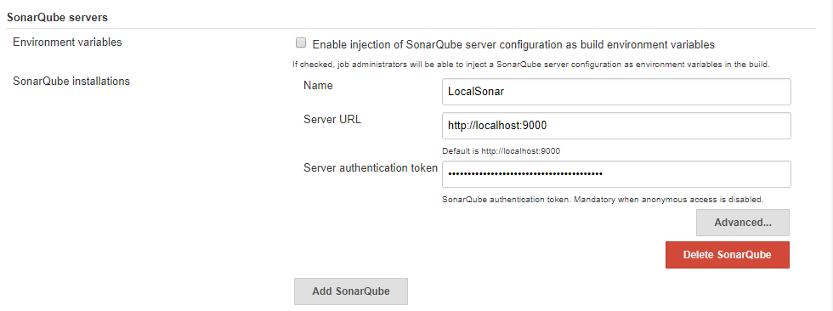

* Go to **Manage Jenkins > Manage Plugins > Available >** Search for**SonarQube Scanner>**click **Install.**

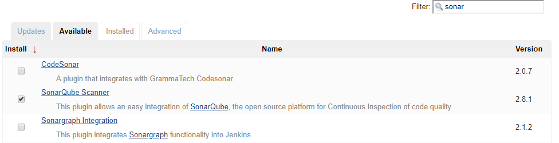

* Go to **Manage Jenkins** > **Global Tool Configuration** > Scroll for **SonarQube Scanner** > Add sonar scanner > provide name, uncheck if you already have sonar > provide path to**sonar runner home**as shown in the below image:

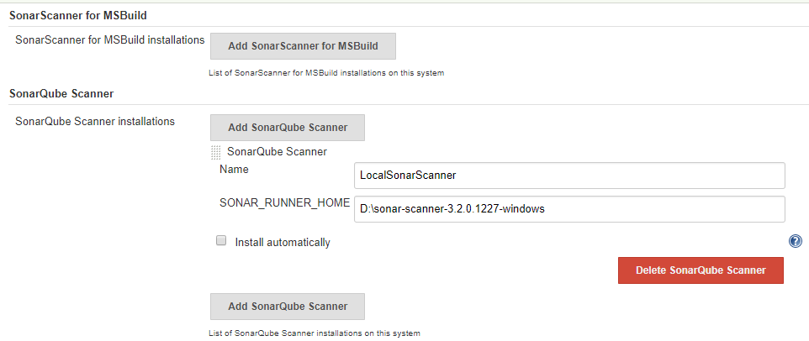

* Create a new job-> provide a name, and select project type as freestyle.
* Set Git under SCM section and use **\* * * * \*** for Poll SCM under the Build Trigger section. Under the Build Environment section, add pre-buid step > select **Execute SonarQube Scanner.**

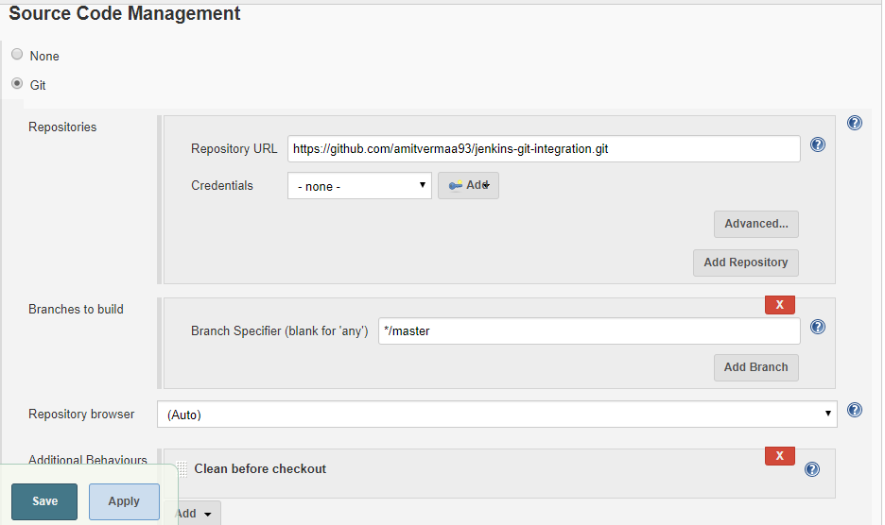

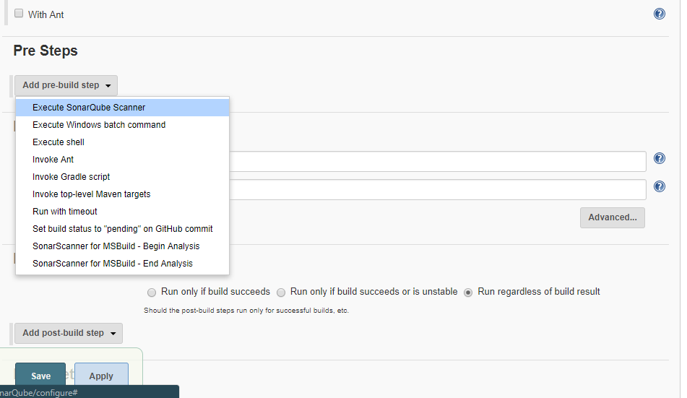

* Create a **.properties** file at any location and provide a path on the task in the **path to project properties** section.
* Inside sonar-scanner.properties, enter below code:

**sonar.projectKey=github-jenkins-sonar  
sonar.sources=./src**

* Build the job and check the report on the SonarQube server.
* From job dashboard, click on sonar icon or navigate to*Sonar server, c*lick on **Projects.**

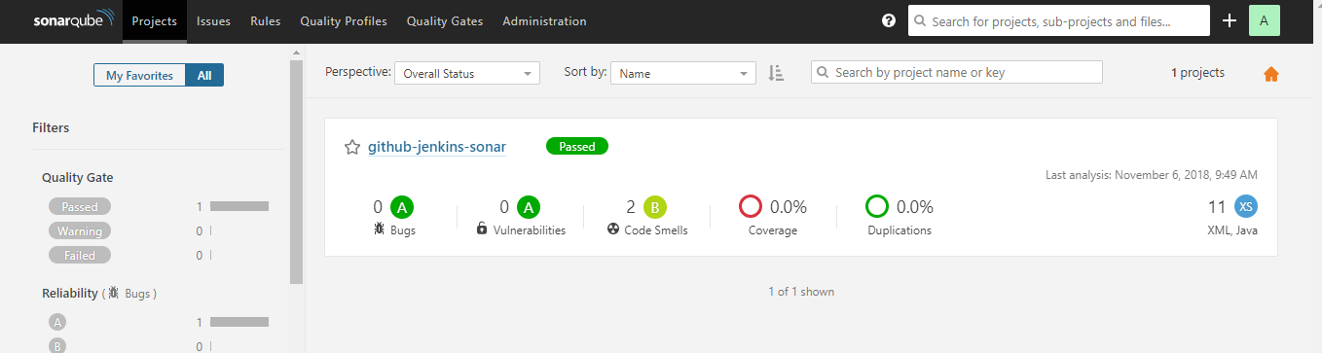

**Step 7.3.3:** Push the code to your GitHub repositories

* Open your command prompt and navigate to the folder where you have created your files.

**cd <folder path>**

* Initialize your repository using the following command:

**git init**

* Add all the files to your Git repository using the following command:

**git add .**

* Commit the changes using the following command:

**git commit . -m “Changes have been committed.”**

* Push the files to the folder you initially created using the following command:

**git push -u origin master**